
Focus group registration form-new for 2026
The development of this group is aimed at professionals who support children and young people who have been separated from their families oversees and who are seeking asylum in the United Kingdom. We are seeking professionals who are employed within a local authority, legal, supported accommodation staff, health etc etc…...We are inclusive and everyone matters
We hope our members can bring to the group good practice, and share experience and skills, we will discuss topics such as when is and when isn’t an age assessment needed and much more. We want active members who can contribute to growing our K&C community,
Now let’s not waste any time and complete the below form to be part of us

Name:

Contact work email:

Contact phone number:

Job title:

Brief description of role:

Which country do you live and practice in?

What do you hope to bring to the group setting?

We want our focus group to be led by our members to ensure that we are addressing the areas of learning that you want to improve. We want our group to be a platform to share experiences, knowledge, good practice and much more and feel safe to share your experiences. To help us to shape the sessions based on your learning needs, we have devised a series of questions below. We appreciate that some of the questions you may not have answers to now, however do not worry as we can revisit these questions again in the future. We really look forward to having you on board
Are you interested in becoming involved in the planning/delivery of group sessions?

Are you interested in being a speaker at a group session in the future?

Do you agree to be an active contributor to the group sessions?

Do you agree to follow the group rules?

Is there a rule that you would like to include?

Please state what topics you would be interested in bringing to the group sessions, and why?

Please state what has led you to want to be part of the focus group?

What do you hope to gain from attending the focus groups?

What would be the ideal times for the focus group sessions to take place to ensure you can attend?

How frequently would you like the group to run?

Is there anything else that you want to include in the sessions?

We want to thank you for your interest in being part of K&C community, it is great to have you on board.
For a copy of our privacy policy and other useful information please visit www.kc-expert-assessment.co.uk Check out our social media QR codes and contact details below.

Thanks,
Kim & Cheryl
K&C Expert Assessments and age assessment specialists

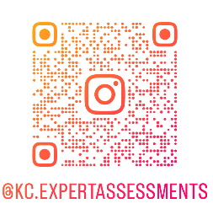

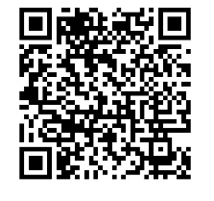
Why not follow us on social media

